

System Analysis and Design
ISYS 10242
Group Report
For: Azi Meskaran
Names:
Seherin Zaman ID: N1406550
Excell Moses Efe ID: N1353358
Swagata Paul ID: N1406668
Hephzibah John Igani ID: T0468665

Table of Contents

1.INTRODUCTION …………………………………………… 4 - 8
1.1 Organizational Overview
1.1.1 Our Philosophy
1.1.2 Our Services
1.1.3 Vision
1.1.4 Mission
1.1.5 System Overview and Identified Problems

1.2 Methodology Selection and Justification
1.2.1 Project Considerations and Constraints
1.2.2 Justification for Selecting Scrum
1.2.2.1 Suitability for Time-Constrained Projects
1.2.2.2 Iterative Development and Continuous Feedback
1.2.2.3 Risk Reduction Through Incremental Delivery
1.2.2.4 Team Collaboration and Productivity
1.2.3 Consideration of Alternative Methodologies
1.2.3.1 Extreme Programming (XP)
1.2.3.2 Rapid Application Development (RAD)
1.2.3.3 Structured Methodologies (Waterfall and Parallel Models)
2. Project Planning …………………………………… 8-16
2.1 Feasibility Study
2.1.1 Technical Feasibility

2.1.2 Economic Feasibility

2.1.3 Organizational Feasibility

3. Requirement Analysis ……………………………… 16- 28
3.1 Requirement Capturing Method
3.1.1 Interview
3.1.1.1 Interview Questions
3.1.1.1.2 One to One Interview Questions
3.1.1.2 Questionnaire
3.2 Requirement Analysis
3.2.1 FUNCTIONAL REQUIREMENTS

4. Use Case Diagram………………………………… 29

4.1 Use Case Analysis – SwiftChat System

5. Class Diagram………………………………………… 30

5.1 Class Diagram Description – SwiftChat System

6. Database Design…………………………………… 31 - 33

6.1 Entity Relation
6.1.1 SQL

6.1.2 SQL Analysis – SwiftChat System

7. UI Design…………………………………………………. 33-38

7.1 UI Screen Descriptions – SwiftChat System
7.2. Administrator Dashboard
7.3 Organization Portal Dashboard

8. Individual Reflection………………………………… 38 -39

9. Reference ……………………………………… 39 - 40


1. INTRODUCTION
1.1 Organisational Overview
AutoFilum is an AI focused tech startup centred around automating business processes and streamlining operations. Filum being the Laton word for thread it’s reflective of our ambition to concisely “thread” together files, connecting then without the need of manual labour while maintain structure, achieved through the use of AI automation, cloud storage and numerous methodologies. Order Automated, Chaos Eliminated, our motto which fully encompasses our promise to all clients.

1.1.1 Our Philosophy
We firmly believe in the philosophy of “WE THREAD FILES. YOU MOVE FORWARD”. Our team consists of top professionals share a common vision and passion, providing our clients with critical insights and advise to succeed in today’s competitive environment. We, as a team, aim for innovation, automation and excellence ensuring providing the highest and best end use of services to our clients.

1.1.2 Our Services
Our company delivers a comprehensive range of IT services, continuously aligning with industry advancements. We proactively embrace emerging technologies, ensuring we evolve with changing trends to provide innovative, efficient, and future-ready solutions.
- App Development
- Web Design
- Software Development
- System Maintenance

1.1.3 Vision
- To be a trusted IT partner for small and growing startups.
• To deliver high-quality, cost-effective solutions without compromising on excellence.
• To integrate AI-driven technologies to solve complex problems and drive innovation.

1.1.4 Mission
To deliver exceptional IT services across app development, software engineering, and database solutions, by leveraging innovative technologies and industry best practices to create reliable, scalable, and high-quality digital solutions that empower businesses to succeed.

1.1.5 System Overview and Identified Problems
SwiftChat is a text file management platform used by medium-sized organisations for handling files, storing chats, audit logs, and messages. Due to SwiftChat’s growth, it has faced several limitations, leading to both long-term and day-to-day complications. These issues include loss of audit logs, inefficient staff time allocation, permission management errors, and security vulnerabilities. The loss of audit data has particularly impacted customer relationships, reducing trust and accountability.
These challenges affect key stakeholders, including both clients and administrative staff, by decreasing operational efficiency and increasing the risk of data mismanagement.
In accordance with our business philosophy, the proposed solution is to develop an automated messaging and collaboration management system. This system will streamline communication while addressing the limitations of the existing platform. It will automate the onboarding process for new users, reducing manual administrative workload and minimizing human error.
The system will utilise cloud-based infrastructure to ensure secure, scalable, and reliable data storage, preventing data loss and enabling real-time access to information. Additionally, it will support the creation of structured customer profiles, allowing organisations to manage user data more efficiently and personalise communication.
Advanced features such as role-based access control will be implemented to resolve permission issues, ensuring that users only access authorised data. Integrated audit logging will track all activities within the system, improving transparency, security, and accountability.
Furthermore, the system will include analytical tools to monitor usage patterns and staff performance, helping organisations optimise resource allocation. By automating routine tasks and improving data management, the proposed system will enhance overall efficiency, strengthen security, and improve customer satisfaction.

1.2 Methodology Selection and Justification
1.2.1 Project Considerations and Constraints
The selection of the development methodology was based on a thorough assessment of key project factors to determine the most effective and appropriate approach. The following considerations were taken into account:
- Limited project budget
- Restricted development timeframe
- Requirement to work with relatively unfamiliar technologies
- Need for clear schedule visibility throughout the project lifecycle
- Well-defined and structured user requirements

1.2.2 Justification for Selecting Scrum
Following detailed discussions with the project team, the SCRUM Agile methodology was selected as the most appropriate development approach. Scrum is an incremental and iterative Agile framework for managing product development, first introduced by Hirotaka Takeuchi and Ikujiro Nonaka in 1986 as a flexible, team-based approach that promotes self-organization, close collaboration, and continuous communication, challenging traditional sequential development methods(Sachdeva, 2016).

1.2.2.1 Suitability for Time-Constrained Projects
This methodology is particularly well-suited to projects with a limited timeframe, such as this one, which is scheduled for completion within six months. Nowadays, most software products and projects operate under tight deadlines and high customer expectations, and to successfully manage these demands while ensuring customer satisfaction, Agile methodology is often the most effective approach (Hema et al., 2020).

1.2.2.2 Iterative Development and Continuous Feedback
SCRUM enables iterative development through short sprints, allowing for regular reviews and continuous feedback from customers and stakeholders. This ensures that the evolving system consistently aligns with user expectations and project objectives. Scrum supports timely feedback through regular sprint reviews and retrospectives, which provide structured and continuous opportunities for immediate and ongoing feedback that enhance learning, improvement, and project quality (Sakhi Aggrawal and Magana, 2024).

1.2.2.3 Risk Reduction Through Incremental Delivery
Furthermore, the iterative delivery of small, functional increments, combined with continuous testing, facilitates the early identification and resolution of issues rather than postponing them until the final stages of development. During retrospectives, the team reviews what worked well and what caused issues in the last iteration, agrees on improvements for the next cycle, and faces the ongoing challenge of effectively tracking identified problems and solutions over time. (Matthies, 2019).

1.2.2.4 Team Collaboration and Productivity
In addition, SCRUM promotes strong team collaboration, structured communication, and regular progress tracking, which enhance organisation, motivation, and overall productivity. Its flexibility also allows for ongoing improvement and the incorporation of new features when required, making it highly adaptable to changing project needs. The Agile approach addresses the inherent unpredictability of software development by adopting an incremental development process, reducing extensive upfront planning and estimation, and promoting continuous communication and close collaboration with the customer. (Hron and Obwegeser, 2018).

1.2.3 Consideration of Alternative Methodologies
1.2.3.1 Extreme Programming (XP)
Initially, XP was considered because of its focus on continuous improvement, testing, and simplicity, which could support automating aspects of the manual process. In Extreme Programming (XP), developers implement the simplest solution that could work, with automated unit tests written beforehand, ensuring that code is only complete when all tests pass, and continuous daily modifications are tested to support ongoing improvement and quality assurance(Crispin and Tip House, 2003). However, Extreme Programming (XP) often emphasizes working code over comprehensive documentation, which can pose challenges in preserving critical knowledge, facilitating team communication and onboarding, supporting maintenance and updates, ensuring compliance with standards, and guiding testing to maintain system quality and continuity. In Extreme Programming (XP), the emphasis on continuous changes often results in insufficient documentation, making it difficult to track unforeseen failures and increasing the overall project risk (Shrivastava et al., 2021). Moreover, Extreme Programming (XP) places a strong emphasis on code, and since the design evolves alongside implementation, there is a risk that the final design may not fully align with customer requirements, potentially compromising the correct implementation of software specifications. XP’s code-centric approach can sometimes lead to misalignment with customer expectations and incomplete adherence to specifications if design and requirements are not carefully managed (Shrivastava et al., 2021). On the other hand, Scrum works best with small teams (usually 3–9 members), making communication, collaboration, and decision-making easy. In Scrum, a development team is generally considered most effective when comprising five to eleven members, with the team size determined collaboratively by the Product Owner and the Scrum Master to optimize productivity and collaboration (Saleh et al., 2019).

1.2.3.2 Rapid Application Development (RAD)
The Rapid Application Development (RAD) model is not well-suited for projects with evolving or unclear requirements, as its effectiveness depends heavily on having clearly defined and well-understood requirements from the outset. “Suitable only when requirements are well known” Khan et al., 2012). Furthermore, although RAD incorporates prototyping to refine system functionality, such approaches often place limited emphasis on formal documentation that can lead to higher maintenance and upgrade costs over time. “Lack of documentation results costly support for upgrading of the software”(Khan et al., 2012).
1.2.3.3 Structured Methodologies (Waterfall and Parallel Models)
Structured Methodologies like waterfall, parallel are also not a wise decision as structured methodologies espeically waterfall l is characterized by its rigid structure, requiring clearly defined and fixed requirements established at the beginning of the project, with limited flexibility to accommodate changes or modifications during the development process. The Waterfall model adopts a sequential approach in which all customer requirements are defined at the beginning and the final product is developed strictly according to those initial specifications(Shrivastava et al., 2021).

2. Project Planning
In this section of the report, the system feasibility will be evaluated across three key dimensions: technical, economic, and organisational feasibility. Following this evaluation, a comprehensive risk assessment will be conducted to identify potential challenges associated with the proposed system. Subsequently, appropriate mitigation strategies and solutions will be proposed to address and minimise the identified risks.

2.1 Feasibility Study
2.1.1 Technical Feasibility
Overview OF Technical Considerations
Description
IIn the existing system, they are using a local server with poor data storage. This will be replaced with a structured database management system where data is efficiently organised, securely stored, and easily retrievable. The new system will enable fast searching, reliable backup, improved data integrity, and better scalability to handle increasing user demand.

Requirements
Software and Hardware

Software
· A Database Management System (DBMS) such as PostgreSQL or MySQL (free and open-source; optional setup/support may cost approximately £500–£1,500 for the project duration).
· Server-side frameworks such as Node.js or Django (free and open-source, no direct cost).
· Cloud platforms such as Microsoft Azure or Amazon Web Services for hosting databases and applications (estimated £1,500–£4,000 for the 5–6 month duration).
· Version control tools such as GitHub (free for basic use; optional team features may cost around £100–£400 for the project duration).
· Security software including SSL/TLS certificates (estimated £100–£300 for the project duration).

Hardware
· Cloud-based servers (recommended for scalability and reliability):
Estimated cost of approximately £1,500–£4,000 for the 5–6 month project duration depending on performance requirements and storage usage.
· Developer workstations (PCs/Laptops):
Typically already available within the organisation; however, if additional devices are required, the estimated cost is £600–£1,200 per device.
· Network infrastructure:
Existing organisational internet and networking systems can be utilised; additional upgrades (if required) may cost approximately £200–£800 .
· Backup storage systems (cloud or external drives):
Estimated cost of approximately £200–£600 for secure data backup during the project duration.

Group Quantity
The team should include at least one member with strong expertise in database design and development, as the system requires the database to be built from scratch.

Skills Needed
- Experience in designing Cloud-based server
- Experience using cloud platforms like Microsoft Azure or Amazon Web Services

Justification
A proper database have to design to replace the old local server.

2.1.2 Economic Feasibility

Overview of Economic Considerations

Description
Economic feasibility evaluates whether the proposed system is financially viable and worth the investment. The client has allocated a budget of £60,000 with a strict timeline of 5 months.
The project will be considered feasible if the total benefits exceed the total costs:
$$\text{Total Benefits}>\text{Total Costs}$$
The system aims to automate processes, reduce manual work, and improve service quality, which will generate both financial and strategic benefits for the company.

Cost Analysis

Development Costs
These are one-time costs required to build the system:
- Development team salaries
- Project management and planning
- System design and coding
- Database and security implementation
- User interface and portal design
- Software tools and licenses
- Cloud setup and deployment
These costs may vary depending on project complexity and additional requirements.

Operational Costs
These are ongoing costs required to maintain the system:
- Cloud hosting and storage fees
- Software updates and licensing renewal
- Hardware maintenance and upgrades
- Security systems (antivirus, encryption)
- Staff training and communication
- Backup systems (e.g., UPS maintenance)
Operational costs are continuous and directly affect system performance and reliability.

Estimated Cost Breakdown
Role / Component | Cost Category | Estimated Cost
Team Leader | Project Management | £5,000
Project Manager | Planning & Management | £10,000
System Development | Development Cost | £25,000
Database & Security Manager | Development Cost | £10,000
Client Experience Manager | UI/UX Cost | £6,000
Cloud Infrastructure | Operational Cost | £4,000
Total |  | £60,000

Benefit Analysis

Tangible Benefits (Measurable)
- Increased sales due to automation and improved efficiency
- Reduced staff costs (less manual work required)
- Faster processing of user requests (chat logs, billing, subscriptions)
- Improved data accuracy and reduced human error

Intangible Benefits (Non-Measurable)
- Improved brand recognition and market value
- Better customer satisfaction and user experience
- Increased trust and reliability
- Opportunity for international expansion and partnerships

Financial Evaluation Methods

1. Net Present Value (NPV)
$$NPV=\text{Present Value of Returns}-\text{Initial Cost}$$
- NPV > 0 → Project is profitable
- NPV = 0 → Break-even
- NPV < 0 → Not feasible
In this project, NPV > 0, so it is financially viable.

2. Return on Investment (ROI)
$$ROI=\frac{\text{Profit}}{\text{Investment}}$$
- Estimated return: £80,000
- Initial investment: £60,000
Project generates profit → Feasible

3. Break-even Point
The point where total revenue equals total cost.
The project is expected to reach break-even and generate profit afterward.

Economic Risks and Mitigation
Risk | Importance | Explanation | Mitigation
Budget Overrun | High | Costs may exceed £60,000 | Strict budget control and feature prioritisation
Cloud Cost Increase | Medium | High storage usage | Use scalable cloud services
Development Delay | High | May exceed 5 months | Use Agile planning and monitoring
Security Cost | Medium | Extra tools needed | Use open-source frameworks
Low User Adoption | Medium | Low revenue generation | Improve marketing and usability
Maintenance Cost | Low | Long-term expenses | Plan maintenance budget

Justification
The project is economically feasible because:
- Total expected benefits are greater than total costs
- Positive NPV and ROI confirm profitability
- Break-even point is achievable
- Risks are identified and manageable
Therefore, investing in this system is financially justified and beneficial for the company.

2.1.3 Organizational Feasibility

Overview of Organizational Considerations

Description
Organizational feasibility evaluates whether the proposed system will be accepted and effectively used by the people within the organization.
The success of this project depends heavily on stakeholders such as employees, management, and customers. The system must meet their requirements and be easy to adopt within the existing work environment.
After analysing the client company “SwiftChat”, its current workflow, and user requirements, it is assumed that the organization can adapt to the new system. However, some risks exist, so this project is considered medium risk.

Stakeholder Considerations
- Employees: Need to adapt from manual to automated system
- Management: Requires better control, monitoring, and decision-making tools
- Customers (Users): Expect fast, reliable, and user-friendly services
Ensuring satisfaction for all stakeholders is essential for successful system implementation.

Organizational Changes and Challenges

1. Transition from Manual to Automated System
- Employees are currently used to manual processes
- May face difficulty adapting to new technology

2. Training Requirement
- Staff need training to use the new system efficiently
- Learning new features like data storage, search, and system navigation

3. System Usability and User Experience
- New system will provide faster services
- Self-service features (account management, subscription changes) improve usability

4. Data Management Improvement
- Old system had poor data storage and data loss issues
- New system ensures secure storage and easy retrieval

5. Security Awareness
- New system requires strong security for user data protection
- Employees must follow proper security practices

6. Organizational Structure Improvement
- Separate portals for users and administration
- Easier management and better workflow separation

Benefits to Organization
- Reduced workload due to automation
- Improved efficiency and productivity
- Better data management and reliability
- Enhanced customer satisfaction
- More structured and modern system environment

Risks and Mitigation
Risk | Explanation | Mitigation
Employee resistance | Staff not comfortable with new system | Provide proper training and support
Lack of skills | Employees unfamiliar with automation | Conduct training sessions
Security risks | Increased dependency on digital system | Implement strong security measures
Adaptation delay | Time needed to adjust | Gradual system implementation
Communication gap | Misunderstanding requirements | Regular stakeholder feedback

Implementation Approach
The project will follow the Scrum methodology:
- Development in small parts (sprints)
- Weekly progress reviews
- Continuous client feedback
- Quick issue identification and improvement

Justification
The project is organizationally feasible because:
- Stakeholders’ needs are clearly identified
- Training and support plans are included
- Risks are manageable with proper strategies
- Agile approach ensures continuous improvement
Therefore, the organization is capable of adopting and benefiting from the new system.

Gantt Chart
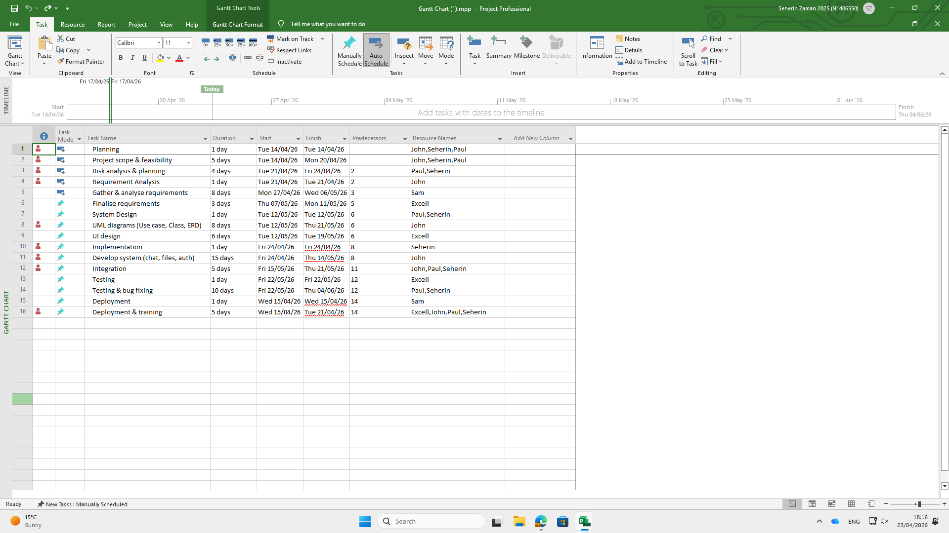
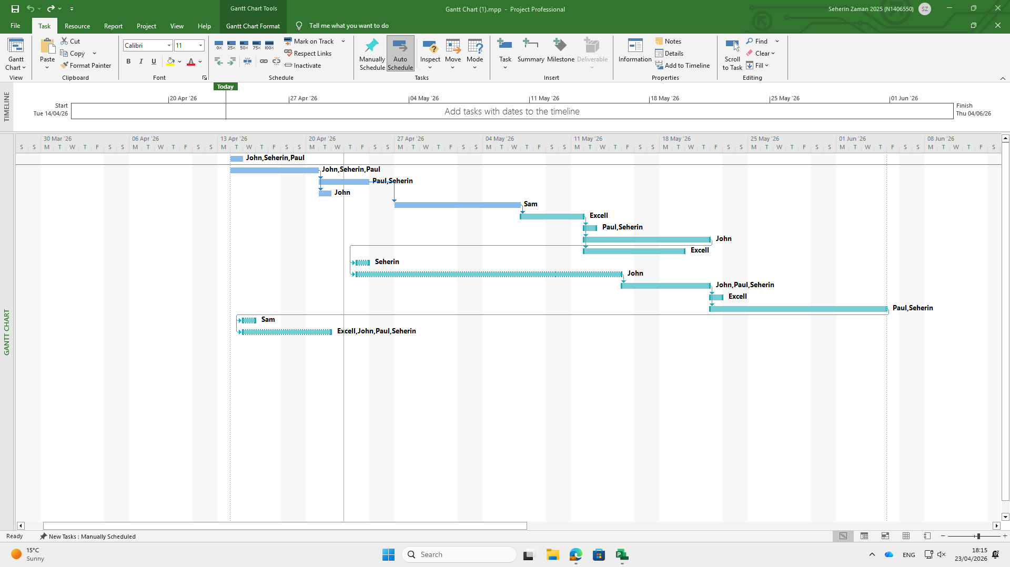
3. Requirement Analysis
3.1 Requirement Capturing Method
After careful consideration of the various existing requirement-capturing methods, our team has agreed that conducting interviews is an effective strategy for gathering requirements from stakeholders. In addition, questionnaires will also be used to collect further information to ensure that the project fulfils all the desired requirements.
3.1.1 Interview

3.1.1 Interview

In the Scrum methodology, communication and feedback are essential for continuous improvement. Conducting interviews enables direct interaction with stakeholders, allowing the team to gather clear requirements and create an interactive environment between stakeholders and the development team. For this reason, the team has decided to implement ‘Interview’ method to collect information.
Stakeholder interviews are essential to extract the drawbacks in the existing system and what are the features they need to their system. This helps to deliver a proper system as it helps to take all the requirements and make the best version of features. Not only that it also helps avoid confusion and future shortcomings.
Stakeholder interviews are essential for identifying the drawbacks of the existing system and understanding the features required in the new system. This helps the development team deliver an effective solution by gathering all the necessary requirements and implementing the most suitable features. Additionally, interviews help to avoid confusion and reduce potential shortcomings in the future.
The interviews will be conducted in two rounds. In the first round, stakeholders will be grouped based on their level of involvement in the project, such as management teams, software developers, investors, and users. In the second round, they will be interviewed one-on-one to ensure better personal interaction and to gather more detailed information.

3.1.1.1 Interview Questions
- Group Interview Questions
Below is the sample questions which maybe asked during grouped interview
.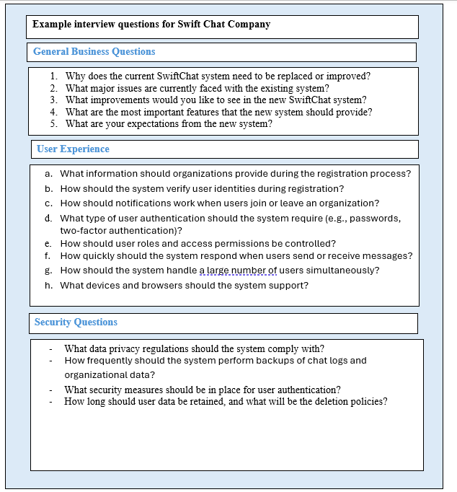

- 3.1.1.1.2 One to One Interview Questions
Interview Questions for Manager Of SwiftChat
Below is the sample questions which maybe asked from SwiftChat Manager.

Example interview questions for Manager

- Do money and time are fixed or changeable?
- What are the main expectations?
- What core features should the business include?
- For what difficulties, the company updating the system?
- Should the system support future growth and more user?

Interview Questions for System Administrator Of SwiftChat
Below is the sample questions which maybe asked from SwiftChaT System Administrator.

Interview Questions for Database Administrator Of SwiftChat
Below is the sample questions which maybe asked from SwiftChaT Database Administrator.

Example interview questions for Database Administrator

- What type of database should be used like SQL or NoSQL?
- What kind of data should be stored/
- How should data security and privacy be handled?
- How long should message and logs be stored?
- How we can ensure rapid data retrieval and search?

Interview Questions for Finance And Accounts Administrator
Below is the sample questions which maybe asked from SwiftChaT Database Administrator.

Example interview questions for Finance And Accounts Administrator

- What payment methods should be accepted?
- How should invoice generated and sent?
- How the payment records should be stored?
- What should happen if a payment is late or fail?
Interview Questions for System Development
Below is the sample questions which maybe asked from Staff.
- What hardware and software they are using and what they require for new system?
- How will they manage data backup and recovery?
- How many users the system need to support?
- What authentication method should be used?
- What should happen if system fails for instance: recovery plan?

Example interview questions for Support Administration or staff

3.2 Questionnaire
- Apart from conducting interviews, our team has also decided to use questionnaires to gather more detailed information. This will help us perform a deeper analysis of the system requirements. The questionnaires will be distributed to administrators, employees, and

- Questionnaire From Employees For Employee Portal
Employees will participate anonymously in the questionnaire to provide a deeper understanding of the features they require. This information will help us design the portal according to their needs and expectations.
SwiftChat

Should employees be able to upload and share files?
Should employees be able to edit or delete their messages?

- YES

B. NO
B. NO
B. NO
Questions For Employees for Employee Portal

- YES
Should employees be able to create their own communication channels?

- YES

Should employees be able to communicate privately with other users?

- YES
B. NO

- Questionnaire From Employees For Administrator Portal

Administrators will participate anonymously in the questionnaire to provide insights into the features and functionalities they need. The information gathered will help us design the administrator portal to better meet their requirements.
- YES

Questions For Administrators for Administrator Portal
SwiftChat
B. NO
B. NO

B. NO

B. NO

B. NO

Should the administrator be able to reset user passwords?
- YES

Should the administrator be able to assign roles and permissions?

Should the administrator be able to view system activity and login logs?
- YES

Should the system perform automatic daily backups?
- YES

- YES

Should the administrator be able to create, delete, and manage user accounts?

- Questionnaire From Manager, Administrators, Employees For Organizational Portal
Employees, administrators, and managers will anonymously complete the questionnaire to share their requirements for the organizational portal. The collected responses will help improve the portal to better meet users’ needs.
B
B. NO
- YES
B. NO
- YES
Should the system be accessible from mobile and web?

Should the admin be able to create, delete, and manage user accounts?
Should the system automatically backup data daily?

B. NO
- YES

Should all messages and files be encrypted for security?
B. NO
- YES
B. NO
Should the system have role-based access (Admin, Manager, Employee)?

- YES
Questions For Manager, Employee, Administrator for Organisational Portal
SwiftChat

3.2 Requirement Analysis
This section depicts both functional and non-functional requirements and emphasize them as below:
M – Mandatory for the system cannot avoid.
D - Desirable requirement. Would be beneficial but can be omitted for different reasons such as budget and time.
O – Optional requirement and it does not significantly effect the system .
I – Improvement. Features only to be consider when mandatory requirements are completed.

3.2.1 FUNCTIONAL REQUIREMENTS

- ORGANIZATIONAL REQUIREMENTS
 | Requirements | Priority
1.1.1 | System will allow organizations to register automatically without any email request. | M
1.1.2 | New system will automatically create workspace for new organization after approval | M
1.1.3 | System shall allow the organizations to configure channel and employee roles | M
1.1.4 | New system will provide that kind of advantage so that that they can add and remove employee. | M
1.1.5 | System will allow organizations to manage subscription and billing details | M
1.1.6 | System shall allow organizations to customize workspace setting like theme, name and others | D
1.1.7 | System shall allow organizations to generate basic usage reports | D
1.1.8 | System may allow organizations to integrate with third-party tools like emails, calendar, reminder | O

- EMPLOYEE REQUIREMENTS
 | Requirements | Priority
1.2.1 | System shall allow employees to send and receive message on time | M
1.2.2 | System should allow employee to search chat history efficiently | M
1.2.3 | System shall allow employees to share files among them | M
1.2.4 | System shall allow employees to access communication channels | M
1.2.5 | System should notify employees on time about notification and keep update | M
1.2.6 | System will allow employees to update their profile information | D
1.2.7 | System should allow employees to mute notification and customize alerts | D
1.2.8 | System may aloe employees to react on message like emoji or like | O

- ADMINISTRATOR REQUIREMENTS
 | Requirements | Priority
1.3.1 | System shall allow administrators to approve organization request and manage user permissions | M
1.3.2 | System will allow them to monitor system use and performance | M
1.3.3 | System will allow administrators to automate billing and invoice generation | M
1.3.4 | System shall allow administrators to retrieve logs and report | M
1.3.5 | System may allow administrators to generate advance analytics reports | D
1.3.6 | System should allow administrators to handle user support request | D
1.3.7 | System allow them to send system-wide announcement | O

3.2.2 Non-Functional Requirements
- PERFORMANCE
 | Requirements | Priority
2.1.1 | System should support multiple organizations and users at the same time without slowing down | M
2.1.2 | The system should respond to the user request within 3 seconds under normal usage | M
2.1.3 | The system should be able to store large volumes of messages, files and billing records efficiently. | M
2.1.4 | The system should continue to perform well as the number of user increase with time | M
2.1.5 | Search result foe message history should be displayed quickly and accurately | D

- SECURITY
 | Requirement | Performance
2.2.1 | User should login securely with username and password | M
2.2.2 | The system should ensure the user can only access data and function based on their role | M
2.2.3 | Sensitive information like password and billing details should be encrypted | M
2.2.4 | The system should keep a secure audit trail of administrative actions | D

- AVAILABILITY

 | Requirement | Priority
2.3.1 | The system should be available 24/7 except maintenance time | M
2.3.2 | The system should provide reliable and recovery in case of failure | M
2.3.3 | The system should be accessible through standard web browser | M
2.3.4 | The system may provide mobile access for users on different kind of devices | O

- USABILITY
 | Requirement | Priority
2.4.1 | The system should have a simple and easy to use interfaces for all | M
2.4.2 | New user should be able to learn the basic functions with minimal training | M
2.4.3 | Error message should be helpful for user | M
2.4.4 | Navigation between messaging, workspace management and other functions should be straightforward | D

4. Use Case Diagram
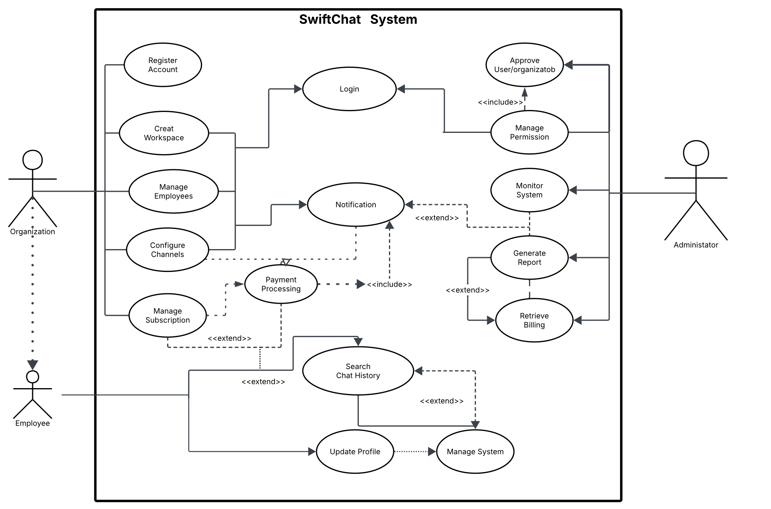
4.1 Use Case Analysis – SwiftChat System
The use case diagram represents the functional requirements of the SwiftChat System and shows interactions between three actors: Organization, Employee, and Administrator.
The primary actors are the Organization and Employee, as they directly use the system. The Organization performs tasks such as registering, logging in, creating workspaces, managing employees, configuring channels, and handling subscriptions. The Employee uses the system to search chat history, update profiles, and receive notifications for daily communication.
The secondary actor is the Administrator, who supports the system by approving users, managing permissions, monitoring activity, generating reports, and handling billing.
The diagram includes UML relationships such as associations, <<include>>, and <<extend>>. For example, login is required before accessing most features, and payment processing is linked to subscription management. Notifications are connected to multiple actions to keep users informed.
Overall, the diagram reflects both communication and administrative processes, showing a complete and realistic system design aligned with real-world business requirements.

5. Class Diagram
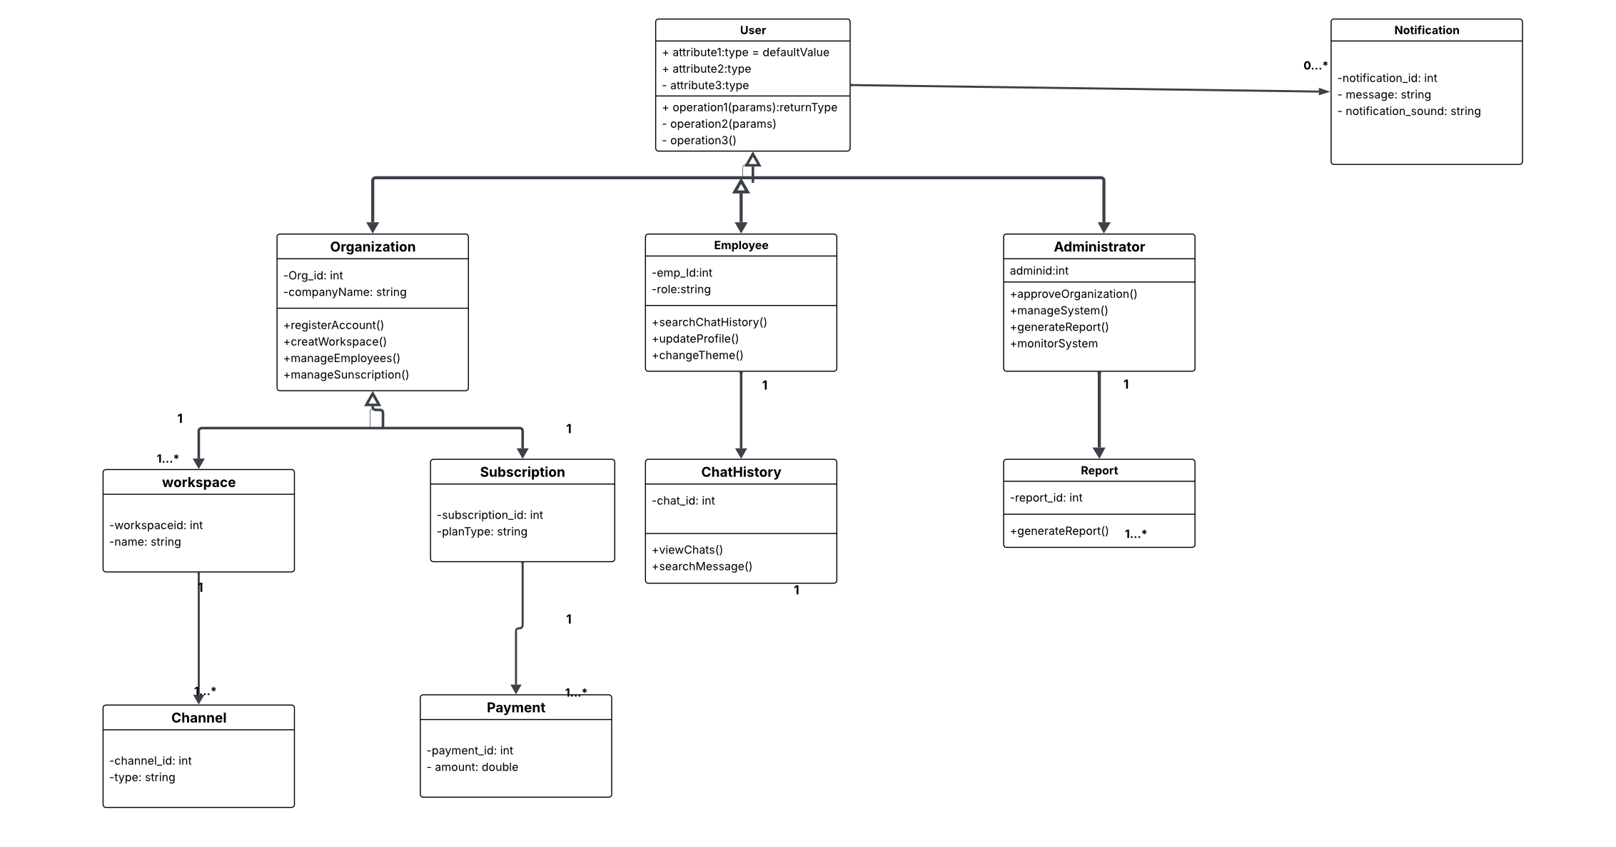

5.1 Class Diagram Description – SwiftChat System
The class diagram for the SwiftChat System demonstrates a comprehensive and well-structured application of object-oriented analysis and design principles, clearly identifying all key classes, their attributes, operations, and relationships.
The design is centred around the User superclass, which is specialised into Organization, Employee, and Administrator through inheritance (generalisation). This approach reduces redundancy and promotes reusability while clearly defining role-specific behaviours. Each subclass has distinct responsibilities: the Organization manages workspaces, employees, and subscriptions; the Employee handles chat interactions and profile management; and the Administrator performs system-level operations such as approval, monitoring, and report generation.
The system is further supported by well-defined classes including Workspace, Channel, Subscription, Payment, ChatHistory, Report, and Notification, which accurately model real-world entities. Relationships between classes are effectively represented using associations and multiplicity, such as one-to-many relationships between Organization and Workspace, and Subscription and Payment, ensuring realistic data modelling.
Key object-oriented principles are clearly demonstrated. Encapsulation is achieved by grouping attributes and methods within each class, while abstraction is shown through the separation of high-level user roles from implementation details. Polymorphism is implied through the shared structure of the User class, allowing different user types to be treated uniformly while maintaining specialised behaviour.
The diagram reflects a clear separation of concerns, ensuring that each class has a single, well-defined responsibility, which improves system maintainability, scalability, and flexibility. Additionally, the design aligns closely with the system’s functional requirements, ensuring consistency between the use case and structural models.
Overall, the class diagram provides a complete, accurate, and logically consistent representation of the system, demonstrating a strong understanding of UML syntax, object-oriented principles, and real-world system modelling, meeting the criteria for an exceptional level of structural analysis.

6. Database Design
6.1 Entity Relation
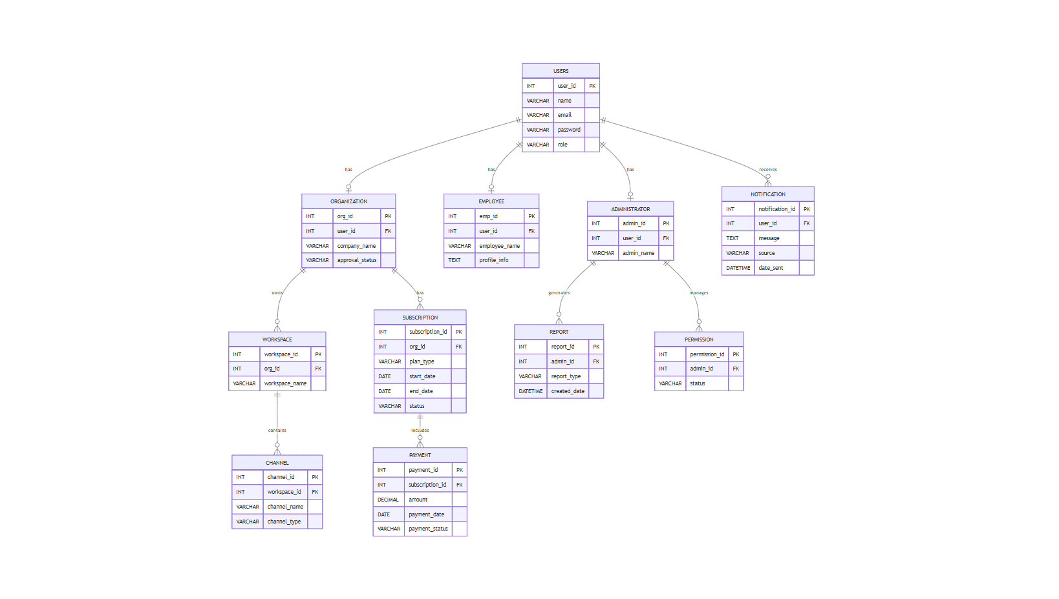
6.1.1 SQL

CREATE TABLE Users (
user_id INT PRIMARY KEY AUTO_INCREMENT,
name VARCHAR(100) NOT NULL,
email VARCHAR(150) NOT NULL UNIQUE,
password VARCHAR(255) NOT NULL,
role VARCHAR(50) NOT NULL
);
CREATE TABLE Organization (
org_id INT PRIMARY KEY AUTO_INCREMENT,
user_id INT NOT NULL,
company_name VARCHAR(150) NOT NULL,
approval_status VARCHAR(50) DEFAULT 'Pending',
FOREIGN KEY (user_id) REFERENCES Users(user_id)
);
CREATE TABLE Employee (
emp_id INT PRIMARY KEY AUTO_INCREMENT,
user_id INT NOT NULL,
employee_name VARCHAR(100) NOT NULL,
profile_info TEXT,
FOREIGN KEY (user_id) REFERENCES Users(user_id)
);
CREATE TABLE Administrator (
admin_id INT PRIMARY KEY AUTO_INCREMENT,
user_id INT NOT NULL,
admin_name VARCHAR(100) NOT NULL,
FOREIGN KEY (user_id) REFERENCES Users(user_id)
);
CREATE TABLE Notification (
notification_id INT PRIMARY KEY AUTO_INCREMENT,
user_id INT NOT NULL,
message TEXT NOT NULL,
source VARCHAR(100),
date_sent DATETIME DEFAULT CURRENT_TIMESTAMP,
FOREIGN KEY (user_id) REFERENCES Users(user_id)
);
CREATE TABLE Workspace (
workspace_id INT PRIMARY KEY AUTO_INCREMENT,
org_id INT NOT NULL,
workspace_name VARCHAR(100) NOT NULL,
FOREIGN KEY (org_id) REFERENCES Organization(org_id)
);

CREATE TABLE Channel (
channel_id INT PRIMARY KEY AUTO_INCREMENT,
workspace_id INT NOT NULL,
channel_name VARCHAR(100) NOT NULL,
channel_type VARCHAR(50),
FOREIGN KEY (workspace_id) REFERENCES Workspace(workspace_id)
);
CREATE TABLE Subscription (
subscription_id INT PRIMARY KEY AUTO_INCREMENT,
org_id INT NOT NULL,
plan_type VARCHAR(50) NOT NULL,
start_date DATE NOT NULL,
end_date DATE,
status VARCHAR(50) DEFAULT 'Active',
FOREIGN KEY (org_id) REFERENCES Organization(org_id)
);
CREATE TABLE Payment (
payment_id INT PRIMARY KEY AUTO_INCREMENT,
subscription_id INT NOT NULL,
amount DECIMAL(10,2) NOT NULL,
payment_date DATE,
payment_status VARCHAR(50),
FOREIGN KEY (subscription_id) REFERENCES Subscription(subscription_id)
);
CREATE TABLE Report (
report_id INT PRIMARY KEY AUTO_INCREMENT,
admin_id INT NOT NULL,
report_type VARCHAR(100),
created_date DATETIME DEFAULT CURRENT_TIMESTAMP,
FOREIGN KEY (admin_id) REFERENCES Administrator(admin_id)
);
CREATE TABLE Permission (
permission_id INT PRIMARY KEY AUTO_INCREMENT,
admin_id INT NOT NULL,
status VARCHAR(50),
FOREIGN KEY (admin_id) REFERENCES Administrator(admin_id)
);

6.1.2 SQL Analysis – SwiftChat System
The SQL design for the SwiftChat System converts the ERD into a structured relational database. Each entity in the diagram is represented as a separate table, with primary keys used to uniquely identify each record and foreign keys used to connect related tables. This ensures the database structure matches the relationships shown in the ERD.
The Users table acts as the central table of the database and stores common user details such as name, email, password, and role. From this table, specialised entities such as Organization, Employee, and Administrator are linked, reflecting the different user roles in the system. This avoids repeated data and improves consistency.
The database also includes functional tables such as Workspace, Channel, Subscription, Payment, Notification, Report, and Permission. These tables support the main operations of the SwiftChat platform, including communication, workspace management, billing, reporting, and access control. For example, an organization can own multiple workspaces, each workspace can contain multiple channels, and each subscription can have related payment records.
The use of foreign key constraints improves referential integrity, meaning invalid relationships cannot be inserted into the database. For example, a payment cannot exist without a valid subscription, and a channel cannot exist without a valid workspace. This makes the system more reliable and reduces data inconsistency.
The database design also demonstrates normalisation, as data is divided into logically related tables rather than stored in one large table. This reduces redundancy, improves storage efficiency, and makes the system easier to maintain and scale. Overall, the SQL design provides a strong foundation for implementing the SwiftChat system in a secure, organised, and efficient way.

7. UI Design
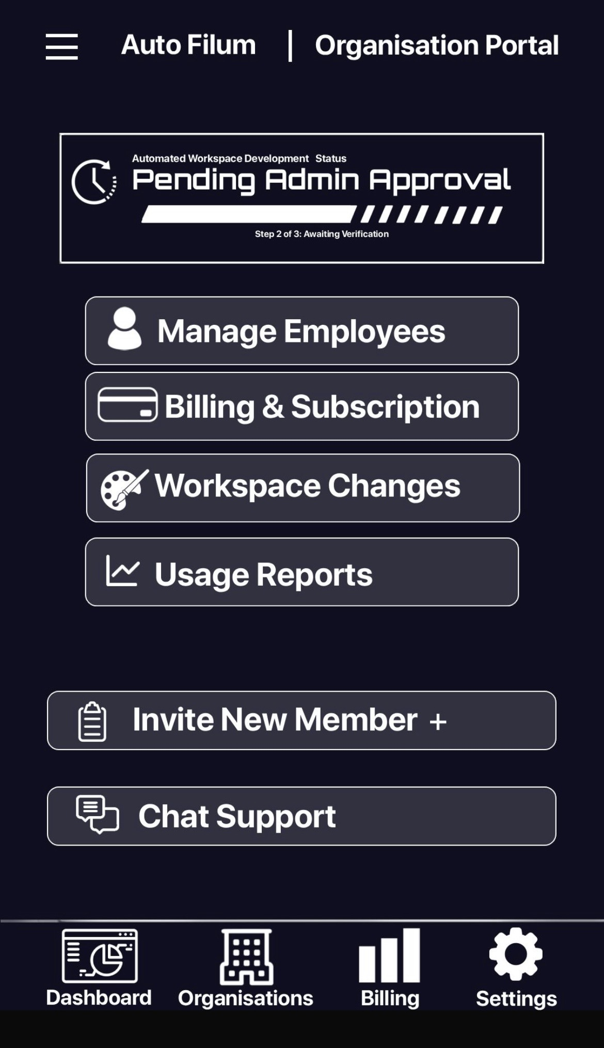
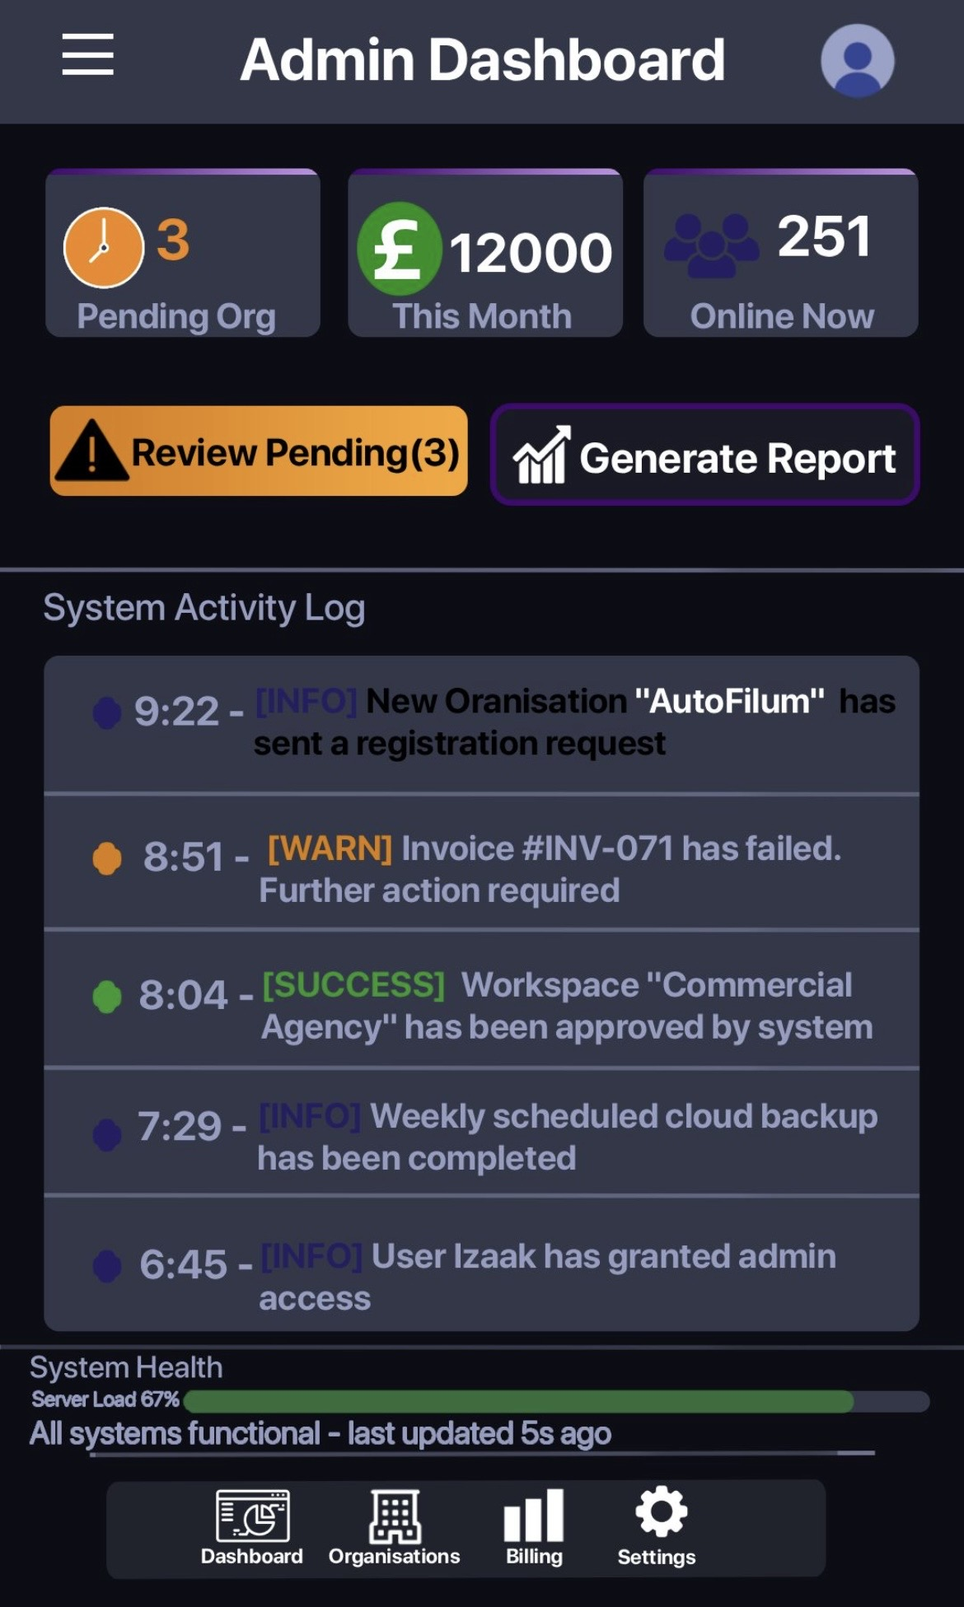
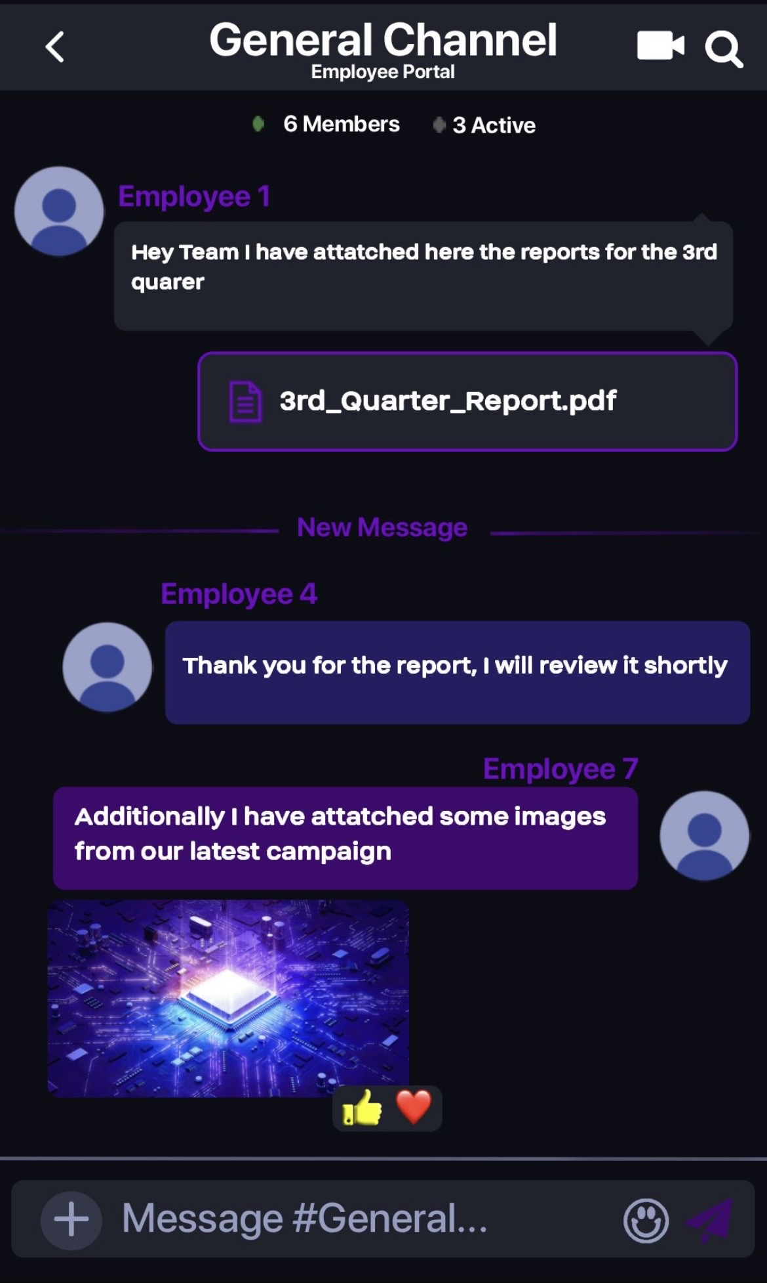
7.1 UI Screen Descriptions – SwiftChat System
7.1.1 Employee Portal – Chat Interface
Purpose
This screen enables employees to communicate and collaborate in real-time within a selected channel.
Main Components
- Top Bar:
  - Channel name (General Channel)
  - Navigation (back button)
  - Call and search icons
- Channel Info:
  - Number of members and active users
- Chat Area:
  - Displays messages from different employees
  - Supports text messages, file attachments (PDF), and images
  - Messages are visually separated by user for clarity
- File Sharing Section:
  - Shows uploaded documents
- Reaction Feature:
  - Users can react with emojis
- Message Input Bar:
  - Add attachments (+), type message, emoji option, send button
Database Connection
- Employee → message sender
- Channel → chat room
- Workspace → grouping of channels
- ChatHistory → messages
- Notification → alerts for new messages
Design Justification
The interface is designed for efficient communication, supporting multimedia sharing and quick interactions, which enhances collaboration within teams.
2. Administrator Dashboard
Purpose
This screen allows administrators to monitor system performance, manage organizations, and take quick actions.
Main Components
- Top Navigation Bar:
  - Dashboard title and user profile
- Summary Cards:
  - Pending Organizations
  - Monthly Revenue (£12000)
  - Active Users (251 online)
- Action Buttons:
  - Review Pending Requests
  - Generate Reports
- System Activity Log:
  - Displays system events (info, warning, success)
  - Example: new organization registration, failed invoice
- System Health Section:
  - Server load indicator (67%)
  - System status confirmation
- Bottom Navigation Menu:
  - Dashboard, Organizations, Billing, Settings
Database Connection
- Organization → pending approvals
- Users → active users
- Payment → revenue
- Report → report generation
- Notification → activity logs
Design Justification
The dashboard provides real-time insights and quick access to critical actions, improving system control and administrative efficiency.

3. Organization Portal Dashboard
Purpose
This screen enables organizations to manage employees, subscriptions, and workspace operations.
Main Components
- Top Bar:
  - Organization name (Auto Filum) and portal label
- Status Panel:
  - Displays Pending Admin Approval with progress indicator
- Main Action Buttons:
  - Manage Employees
  - Billing & Subscription
  - Workspace Changes
  - Usage Reports
- Additional Features:
  - Invite New Member
  - Chat Support
- Bottom Navigation Menu:
  - Dashboard, Organizations, Billing, Settings
Database Connection
- Organization → approval status
- Employee → employee management
- Subscription → plan details
- Payment → billing
- Workspace → workspace updates
Design Justification
The interface focuses on quick access to key management features, allowing organizations to efficiently control their workspace and resources.

8. Individual Reflection

Excell Moses Efe
As a group leader and UI designer, my task was to design UI based on the database. I have made 3 portals – Organizational, Employee and Administrator. Besides, I have assisted in Introduction. Additionally, I have designed the logo of the company.

Swagata Paul
I have worked as a System Designer in this project. I have created Use Case Diagram, Class Diagram. Also I have listed feasibility, functional and non-functional requirements and done risk assessments. Besides, I have assisted in Introduction and requirement gathering. Moreover, I with other two member worked together on Database section.

Seherin Zaman
My role for this project is Business Analyst. For our group project, I have contributed on several components. My contribution to the project included structuring and editing the final report, defining the introduction and the development methodology, structuring interview questions for requirement gatherings and generating idea on functional and non-functional requirements. Additionally, I have assisted (written description) in Use Case Diagram, Class Diagram, and UI. Moreover, I have worked on Database section with other two team members. Beside this, I have reviewed , changed and edited feasibility and risk assessment which was done by another member. I have also managed the work flow of or team.

Hephzibah John Lgani
In this project, I worked as a Project Manager and Database Designer. I am responsible of creating Gantt Chart. Also I have made the primary database which was later used as a base database for our final database design.

Reference

Crispin, Lisa, and Tip House. Testing Extreme Programming. Reading, Mass. ; Harlow, Addison-Wesley, 2003.
Hema, Valpadasu, et al. “Scrum: An Effective Software Development Agile Tool.” IOP Conference Series: Materials Science and Engineering, vol. 981, no. 981, 5 Dec. 2020, p. 022060, iopscience.iop.org/article/10.1088/1757-899X/981/2/022060, https://doi.org/10.1088/1757-899x/981/2/022060.
Hron, Michal, and Nikolaus Obwegeser. Scrum in Practice: An Overview of Scrum Adaptations. Proceedings of the 51st Hawaii International Conference on System Sciences, 2018, pure.au.dk/ws/files/140614726/paper0681.pdf. Accessed Feb. 28AD.
Khan, Asif Irshad, et al. “A Comprehensive Study of Commonly Practiced Heavy & Light Weight Software Methodologies.” ArXiv:1202.2514 [Cs], 12 Feb. 2012, arxiv.org/abs/1202.2514 .
Matthies, Christoph. “Feedback in Scrum: Data-Informed Retrospectives.” 2019 IEEE/ACM 41st International Conference on Software Engineering: Companion Proceedings (ICSE-Companion), May 2019, https://doi.org/10.1109/icse-companion.2019.00081. Accessed 31 Mar. 2022.
Naz, Riffat, et al. “Scrum-Based Methodology for Product Maintenance and Support.” International Journal of Engineering and Manufacturing, vol. 6, no. 1, 8 Jan. 2016, pp. 10–27, https://doi.org/10.5815/ijem.2016.01.02.
Sakhi Aggrawal, and Alejandra J Magana. “Effectiveness of Scrum in Enhancing Feedback Accessibility among Undergraduate Research Students: Insights from Integrated Feedback Dynamics Framework.” Asee.org, 23 June 2024, peer.asee.org/effectiveness-of-scrum-in-enhancing-feedback-accessibility-among-undergraduate-research-students-insights-from-integrated-feedback-dynamics-framework.
Saleh, Sabbir M., et al. “Comparative Study within Scrum, Kanban, XP Focused on Their Practices.” 2019 International Conference on Electrical, Computer and Communication Engineering (ECCE), Feb. 2019, https://doi.org/10.1109/ecace.2019.8679334.
Sachdeva, S. (2016) ‘Scrum methodology’, International Journal of Engineering and Computer Science, 5(6), pp. 16792–16799.
Shrivastava, Anchit, et al. “A Systematic Review on Extreme Programming.” Journal of Physics: Conference Series, vol. 1969, no. 1,1 July 2021, p. 012046, iopscience.iop.org/article/10.1088/1742-6596/1969/1/012046, https://doi.org/10.1088/1742-6596/1969/1/012046.

